**Sending Email Notification to the user who not been logged in from 1 year**

*Creating Event Registry:*

Performance Analytics > System > Event Registry

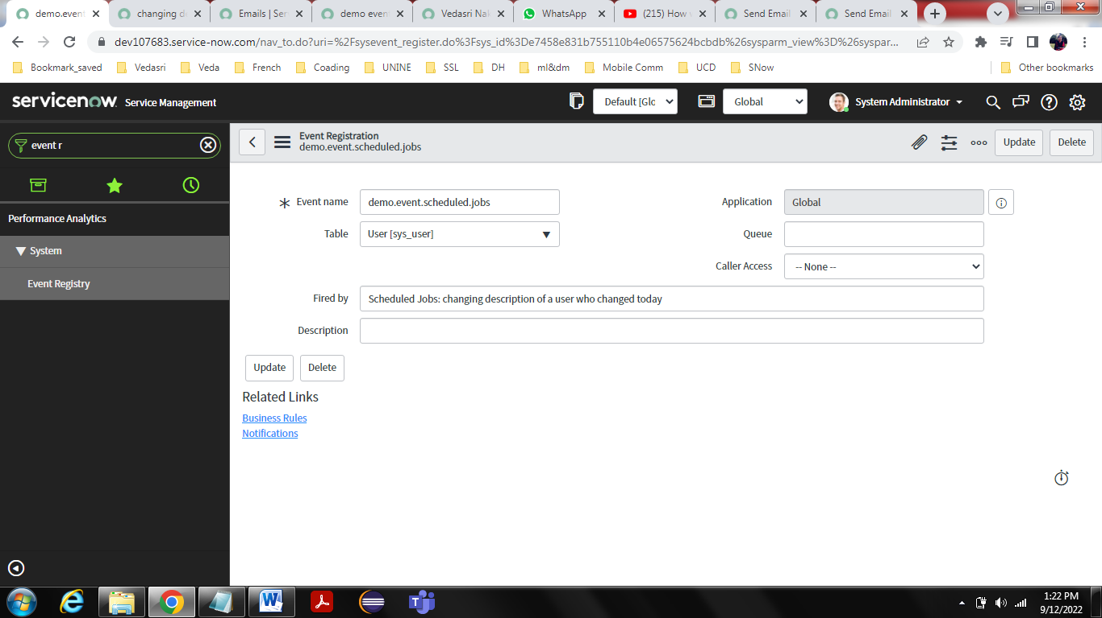

*Scheduled Job:*

System Definitions > Scheduled Jobs

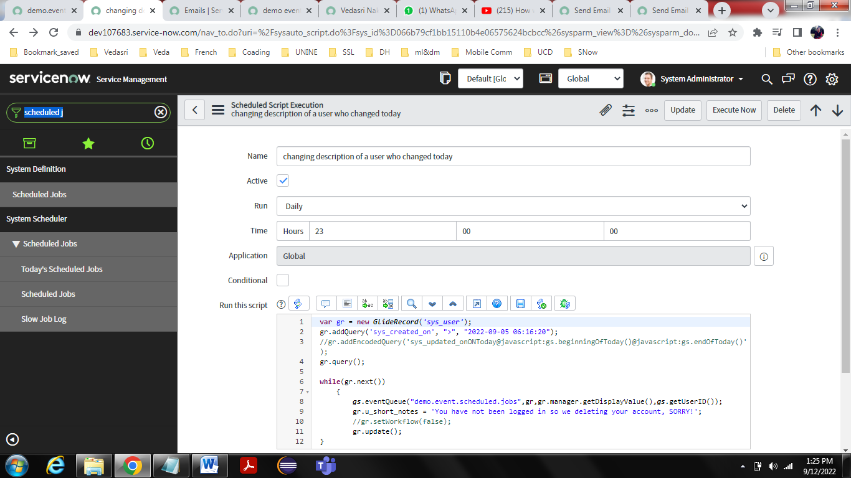

Code:

var gr = new GlideRecord('sys_user');

gr.addQuery('sys_created_on', ">", "2022-09-05 06:16:20");

//gr.addEncodedQuery('sys_updated_onONToday@javascript:gs.beginningOfToday()@javascript:gs.endOfToday()');

gr.query();

while(gr.next())

{

gs.eventQueue("demo.event.scheduled.jobs",gr,gr.manager.getDisplayValue(),gs.getUserID());

gr.u_short_notes = 'You have not been logged in so we deleting your account, SORRY!';

//gr.setWorkflow(false);

gr.update();

}

*Notification:*

System Notification > Email > Notifications

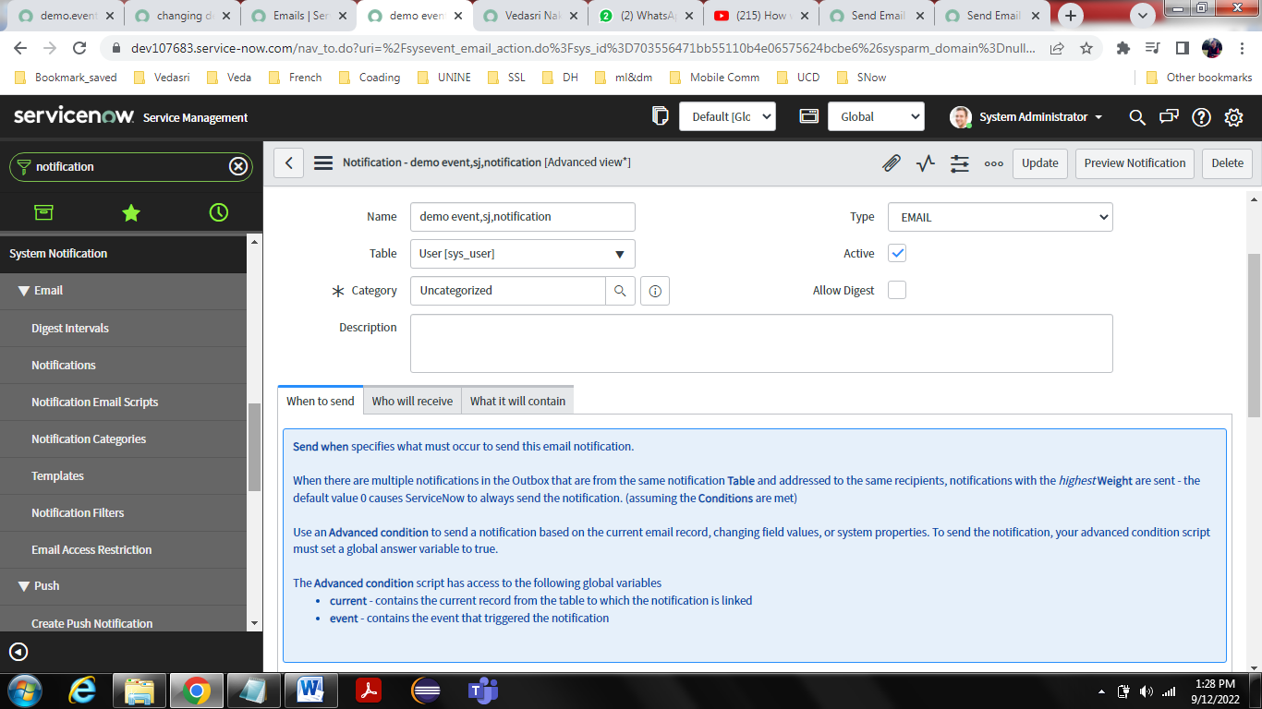

When to send:

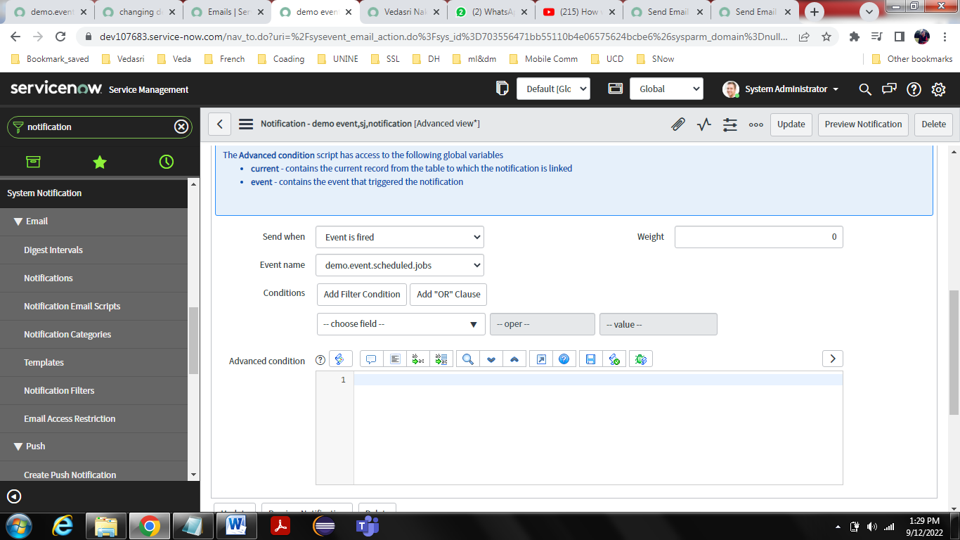

Who will receive:

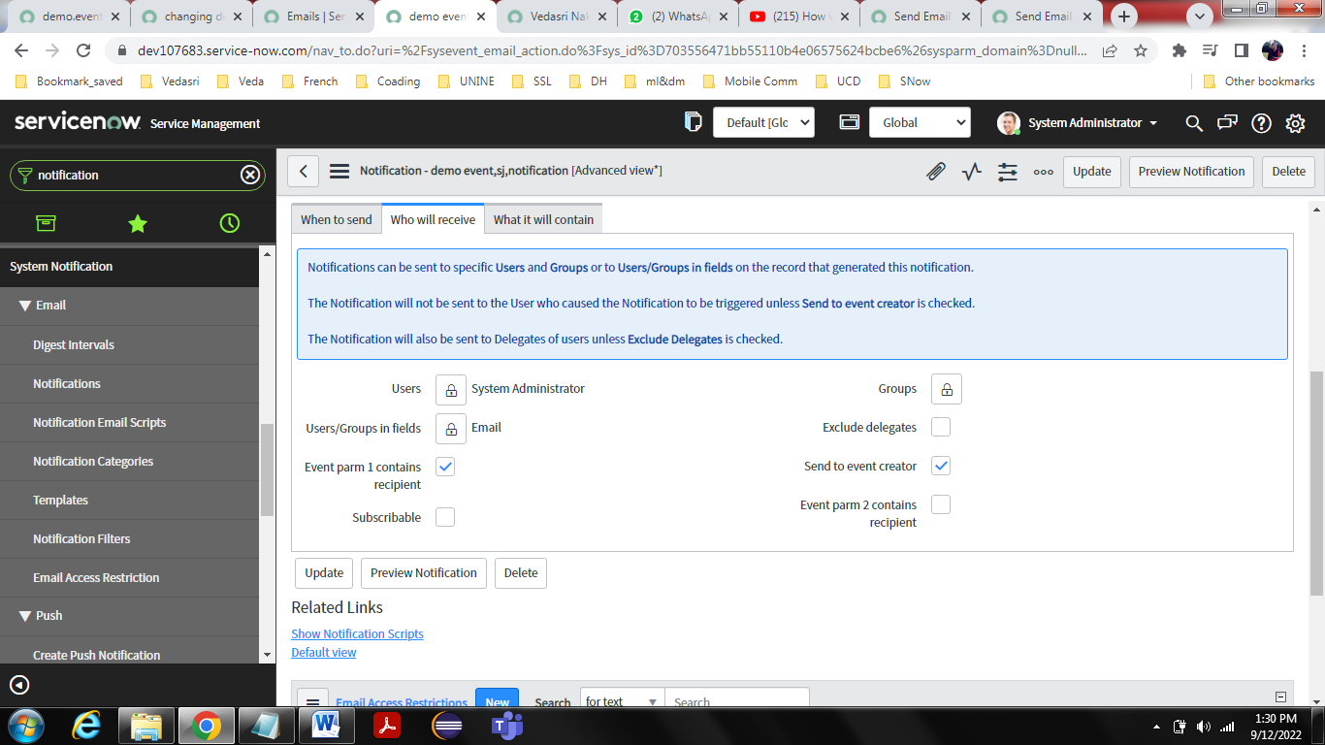

What it will contain:

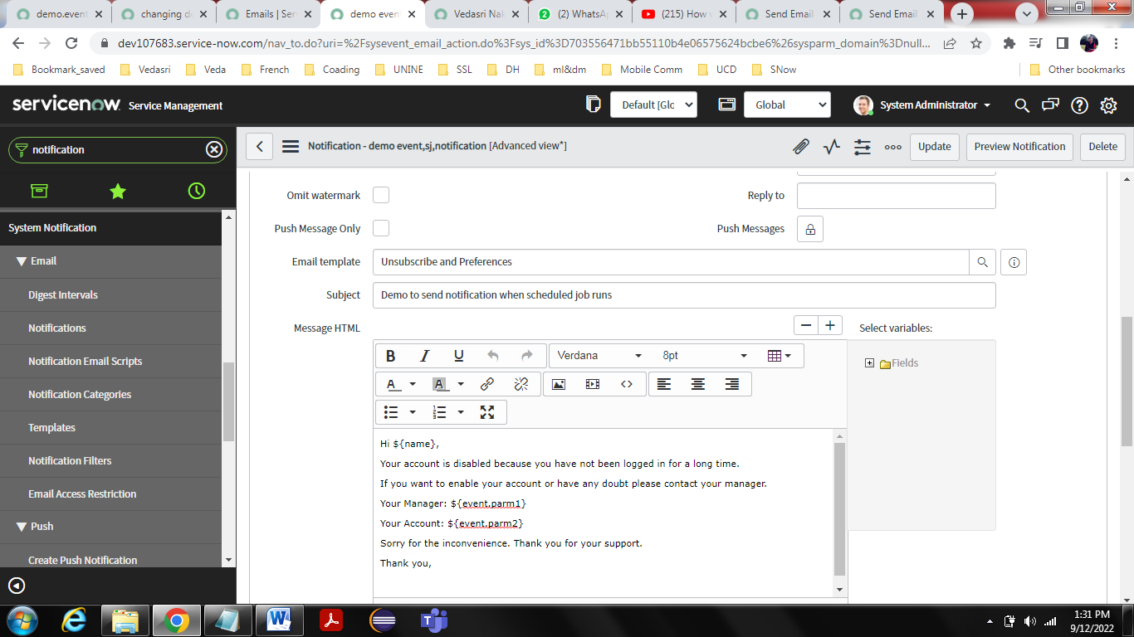

**Result:**

System logs > Emails

Before Scheduled job triggers

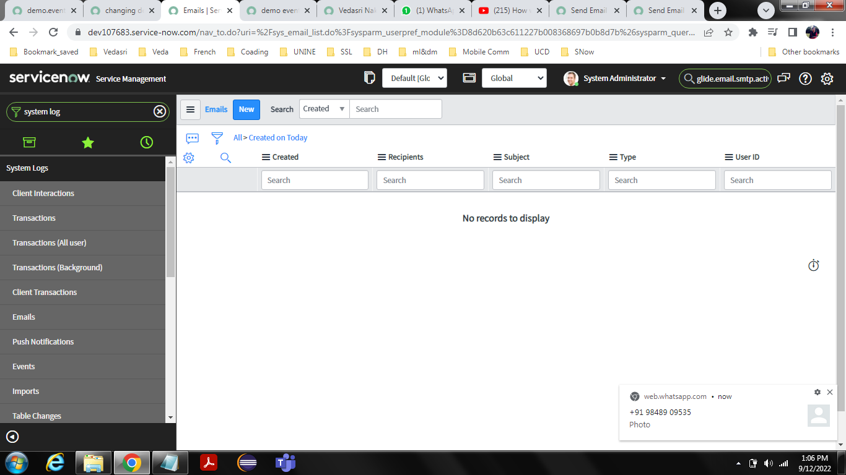

After scheduled job trigger

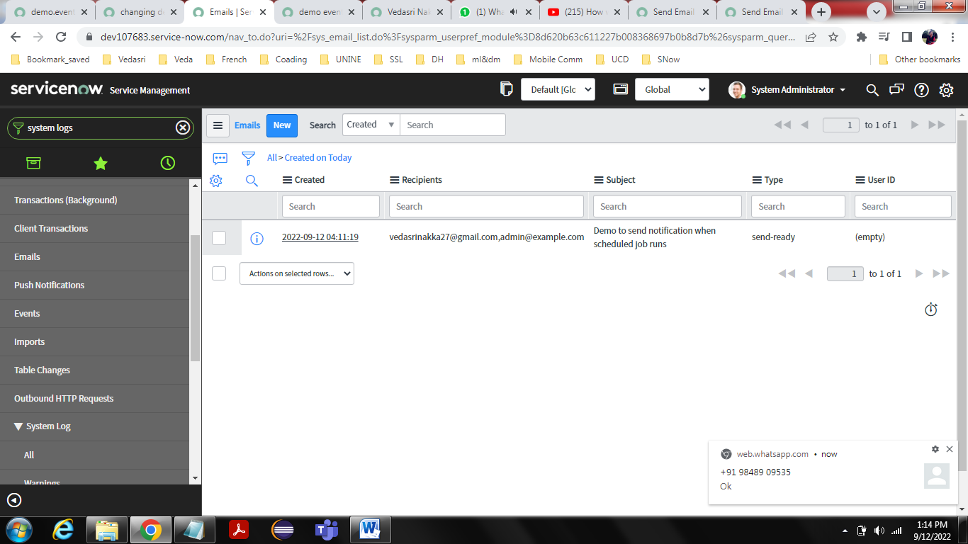

System logs > Events

